 | Heathfield Sixth Form  16–19 Bursary Application

16 – 19 Bursary Fund

To be eligible to receive a bursary you must:
- be over 16 and under 19 years of age on 31 August 2026 or continuing a study programme started at the College when within this age bracket.
- Employment Support Allowance and Disability Living Allowance or
- have a household income of £40,000 or less

For further details please visit https://www.gov.uk/1619-bursary-fund/what-youll-get

The College will also consider applications from any student who during their time at College faces significant financial hardship, due to changes in personal circumstances, such as redundancy and who needs support to complete their studies. By applying for a bursary, you are giving your consent for us to process your personal data in order to check your application and make the bursary payments possible. You may withdraw your consent at any time by emailing kreed@heathfieldcc.co.uk. If you do withdraw your consent, bursary payments will stop.

Bursaries for travel will not be payable to students receiving the Vulnerable Bursary.

No guarantee can be given that funds will be available when you apply. If there is high demand on the funds, awards may be given at a reduced rate. The fund will close when fully allocated.

If your attendance falls below 95% then payments may not be authorised, if your attendance falls below 90% your bursary will be stopped. If you withdraw from your courses the college reserves the right to reclaim any award given.

The Bursary fund is in two parts:

- Vulnerable Bursary (£1200 per year)
This Bursary is available to students who are receiving Income Support or Universal Credit because they are financially supporting themselves and anyone who is dependent on them and living with them, such as a child or a partner.

The defined vulnerable groups are students who are:
- in care
- care leavers
- receiving Income Support (IS), or Universal Credit (UC) because they are financially supporting themselves or financially supporting themselves and someone who is dependent on them and living with them, such as a child or partner
- receiving Disability Living Allowance (DLA) or Personal Independence Payments (PIP) in their own right as well as Employment and Support Allowance (ESA) or UC in their own right

- Discretionary Bursary Tier 1 (Eligibility: Household income of £40,000 or less)
This fund is available to support students towards the cost of travel to the college, textbooks and revision guides, CRB checks, print credits, examination re-sits, educational visits that are essential for your course, UCAS application fees, travel for university interviews and open day visits (maximum of 3 open day visits), stationery (maximum of £50 per year) and essential subject materials. You should seek agreement for any items and claims above £50 before purchasing.

- Discretionary Transport Bursary Tier 2 (Eligibility: Household income of £50,000 or less)
This fund is available to support students towards the cost of travel to the College if they are travelling 3 miles or further. The amount of support being awarded will be confirmed following the receipt of applications.

Heathfield Sixth Form
16–19 Bursary Application

16 – 19 Bursary Fund 2026/2027

First Name |  |  | Family Name
Address
Post Code
Date of Birth |  |  | Age on 31 August 2026
Subjects Studying
Have you received any financial support from any other College/Sixth Form for a course starting September 2026 onwards? |  |  |  |  | YES ☐  NO ☐
If YES, please give College / Sixth Form name and amount

Section 1: Vulnerable Bursary (£1200 per year or pro-rata)

Please tick | About You | Evidence Required (Please supply photocopies)
 | I am in care or leaving care | A letter from the Local Authority or your support worker to confirm your current or previous looked-after status
 | I am in receipt of Income Support / Universal Credit | Your most recent Income Support letter dated within 3 months of the start of your courses
 | I am in receipt of DLA or PIP as well as ESA or UC | Your most recent DLA letter and evidence of receipt of ESA dated within 3 months of the start of your courses

You may also apply for an award from the Discretionary Bursary Fund if you need support with your course costs.

Section 2a: Discretionary Bursary Fund

Please tick the one that applies to you | About You | Evidence of Income:  Please supply one type of evidence of your income from the list below:
 | I live independently and my income is £40,000 or less | - the last 3 months payslips  - P60  - Most Recent Tax Return  - Universal Credit monthly award notice  Please complete the evidence commentary under Section 4
 | I live with my parent/guardian(s) and their income is £40,000 or less
 | I live with my spouse/partner and our joint income is £40,000 or less
 | Other – please describe:

I can confirm that evidence given is for all members of the household. | Yes: ☐
I can confirm, to the best of my knowledge, that the evidence supplied shows that I meet one of the thresholds outlined above for the Discretionary Bursary. | Yes: ☐

Please complete the following for each parent/guardian evidence is being submitted for

Name of parent/guardian
Evidence provided
Total amount of income for named parent/guardian included in evidence |  | £
Additional space for commentary if required

Name of parent/guardian
Evidence provided
Total amount of income for named parent/guardian included in evidence |  | £
Additional space for commentary if required

If further space is required please continue on additional paper.

Section 2b:

Travel Bursaries

If you are successful with your Discretionary Bursary Fund application. You must live 3 or more miles away from the college to be eligible for a travel bursary.

We will confirm amounts of support that can be offered following the receipt of bursary applications at the start of the academic year.

Bursary payments are based on 95% attendance and punctuality to lessons (including independent supervised study sessions), PSHE when required, required registrations, enrichment assemblies and appointments including those with coaches, 6th Form Pastoral Manager, Head of Years 12 & 13 and Director of Key Stage 5. Your achievement and conduct will also be monitored. Not meeting deadlines will be construed as a breach of your contract as study periods are not being used effectively. When recording absences all attendance procedures should be followed as outlined in the Handbook.

Section 3: Bank Details

Awards will be paid directly to your bank account using BACS – please complete your bank details below. Please note that the bank account must be in the name of the student.

Full Name of Account Holder

Name of Bank/Building Society

Branch Name

Sort Code

Account Number /
Roll Number

If you have given details of a building society account, enter the roll or reference number if applicable. Enter this exactly as it appears on your statement/passbook including any hyphens (-) or slashes (/) that are shown as part of the number.

Section 4: Declaration

- I certify the information I have given in this application is true and accurate
- If I withdraw from my courses, I understand that I may be required to repay some or all of any award made
- I understand that if my attendance or behaviour is below a satisfactory standard, my award may be stopped
- I understand that my application may take up to six weeks from the beginning of term to process
- I understand that there is no guarantee that funds will be available when I apply and that if there is a high demand on the funds, awards may be given at a reduced rate
- I have read and understood this declaration

Signature of Applicant |  | Date

Signature of Parent/Carer |  | Date

FOR OFFICE USE ONLY
When processing Bursary applications please complete the following information and refer to guidance issued by the Education & Skills Funding Agency (2025/26 Guidance)
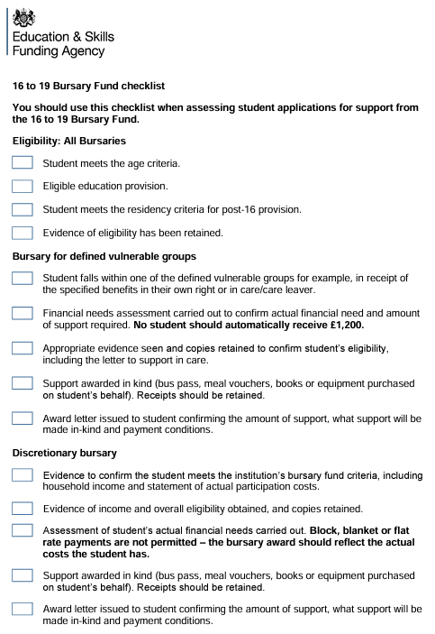
Application Confirmation
Bursary Awarded | Vulnerable Bursary |  |  | Tier 1 Discretionary |  | Tier 2 Discretionary
Application agreed  Communication to be sent |  | ☐ | Signed |  |  |  | Date
Application declined  Communication to be sent |  | ☐ | Name

Your data is processed in line with our Privacy Policy and Privacy notice, which can be found on the policies page of the College website: http://www.heathfieldcc.co.uk/?page_id=1595711
All personal data that you share is processed in line with our privacy policy and privacy notices, which can be found on the policies page of the College website: http://www.heathfieldcc.co.uk/?page_id=1595711

